The Full Report for Power BI with Screenshots and Description

# Chapter 1: Basic Analysis on one Primary file, asx200.

This is after importing the CSV file.

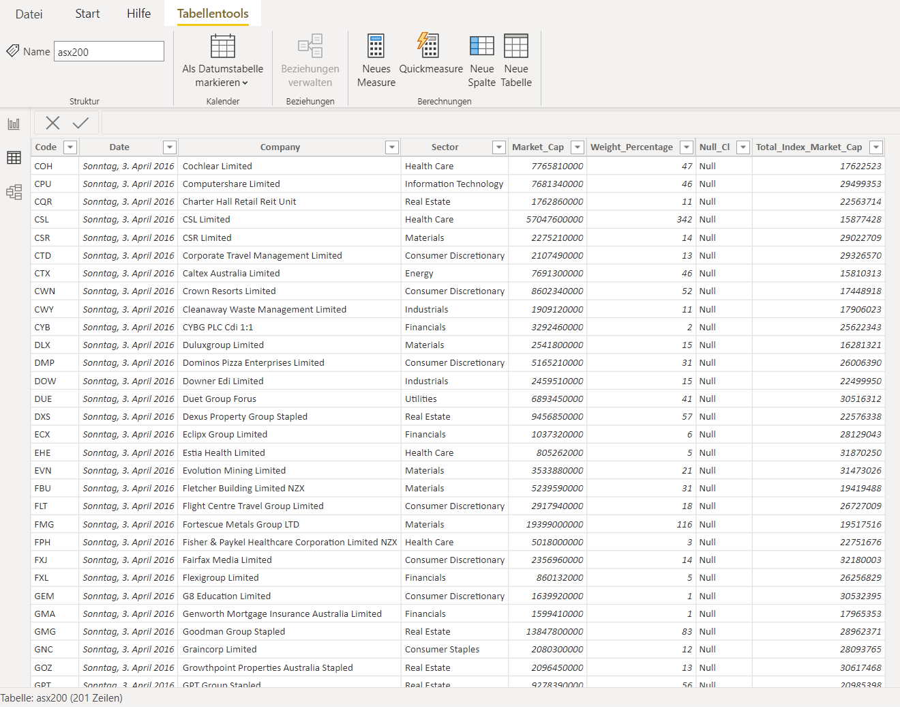

Removing the “Null_CI” column as it is not in need.

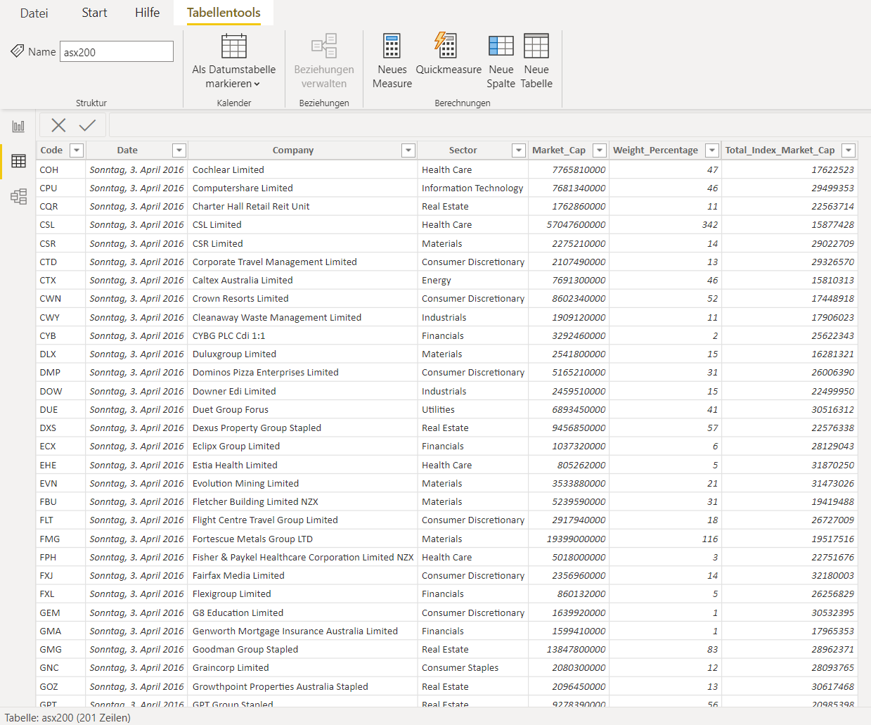

Providing a table of some necessary columns, showing the sum of market cap and weight after sorting them out.

Then as we need all data to look at, click the “don’t summarize” button.

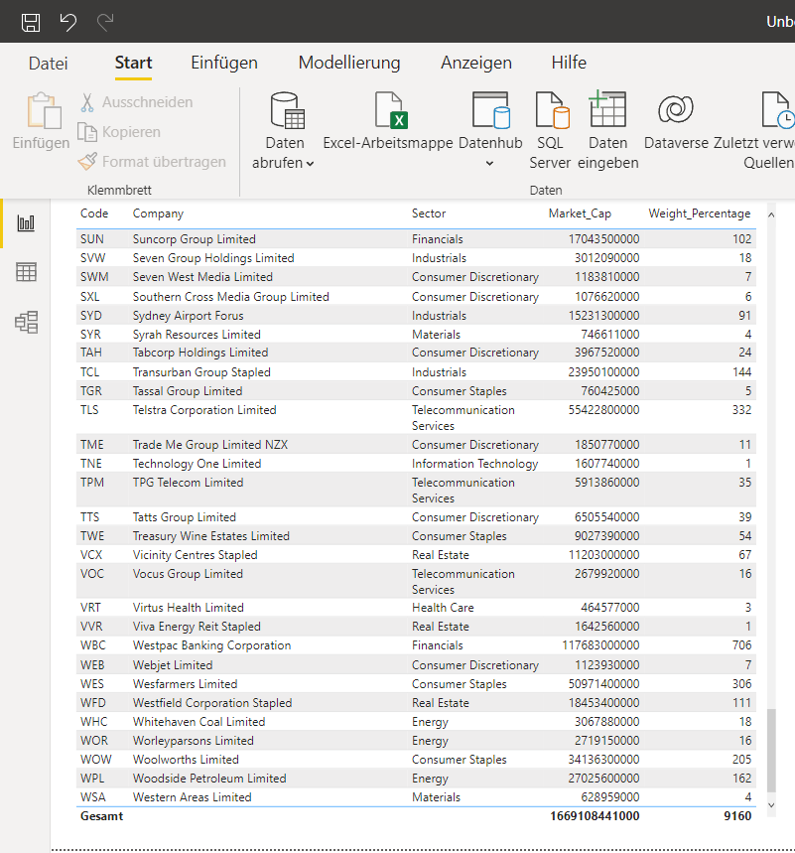

Adding three cards of Market Cap and three slicers of Sector, Market Cap, and Weight.

At this screenshot, the whole data have been selected, so the figures in cards are in total. It shows 200 companies, about 2 trillion Dollar market cap and 148 billion Dollar as the maximum market cap.

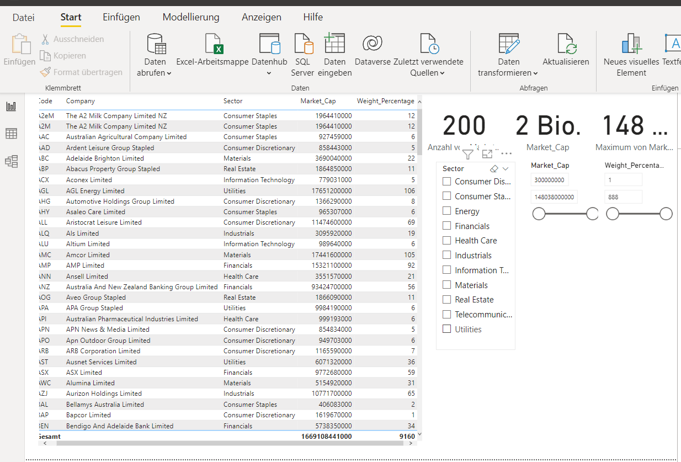

At this stage, it is important to be able to focus on Energy and Health Care sectors as these are directly related to the environment and humans.

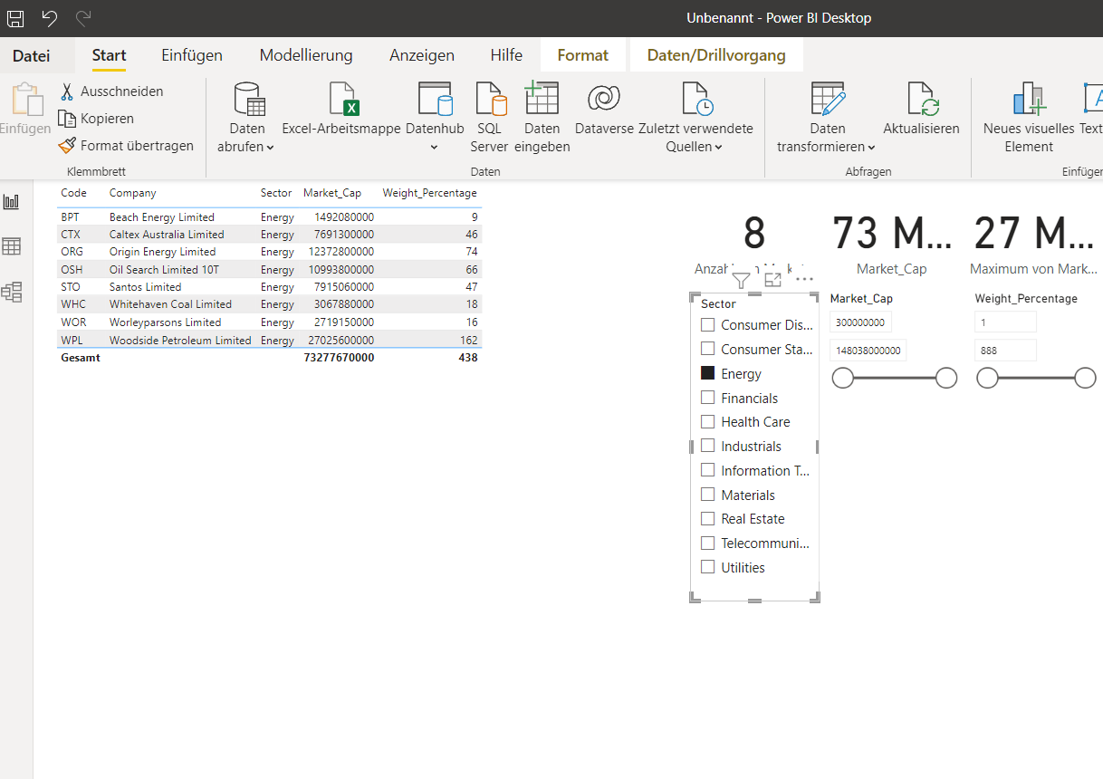

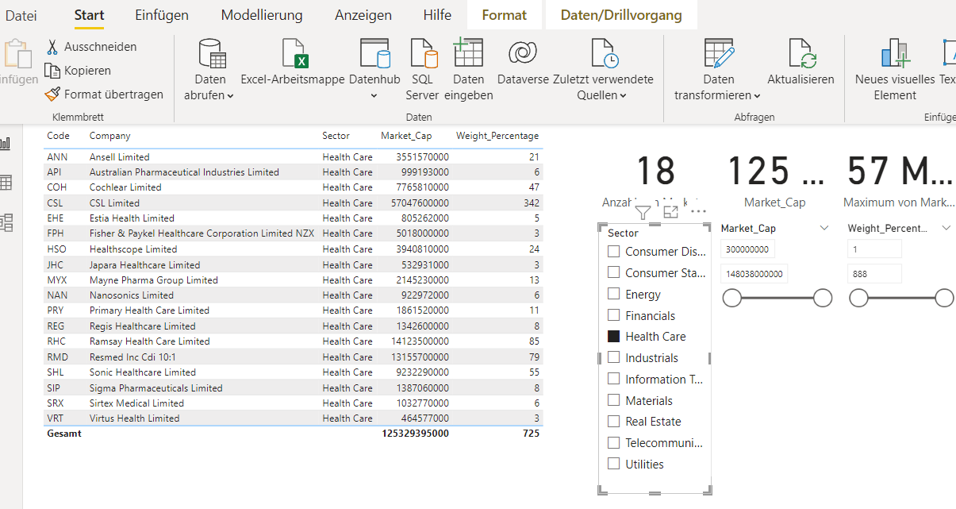

To make it visually improved, let us use some of effects.

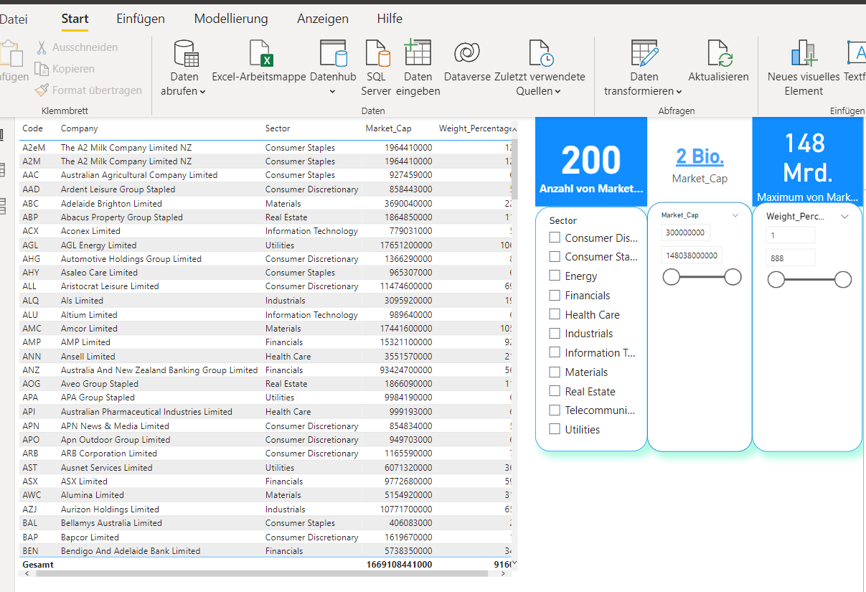

Query:

What is the comparison of four sectors, Energy, Health Care, Materials, and Finances, including some companies from each one in a visualization manner.

To solve this problem, it is desirable to choose some codes/companies from the relevant sectors. To do this process we can either sorting the column of sector in the main table or choosing the desired sectors from the sector slicer.

Then it will be complete by applying a pie chart of four mentioned sectors, a horizontal bar chart of all companies, and a waterfall chart of four sectors with some of their companies.

The general result is as below.

The Finance sector is the largest with more than half of the group individually. After that is the Materials with about one-fourth, while the energy sector contains the least amount of all, a bit less than 7 percent.

In bar chart, it is significant that the company named common wealth bank of Australia is the largest in terms of market cap and the second one Westpac Banking Corporation.

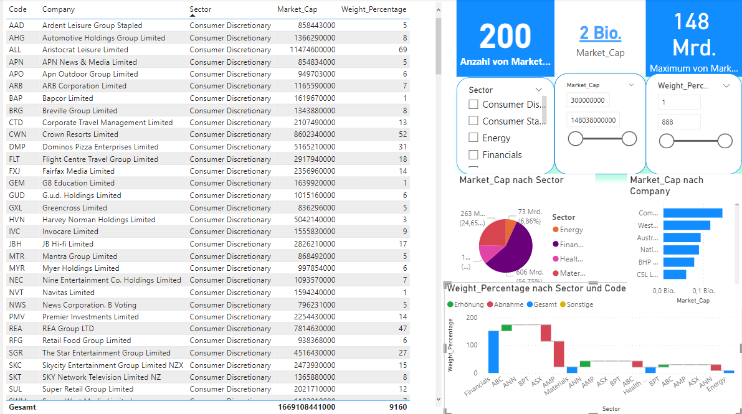

Query:

What is the result of the last analysis for only those market caps greater than 100 billion Dollar.

To do that, simply change the bottom limitation in the slicer of Market Cap to this number and then choose the companies in waterfall chart.

The result would be only two companies that were named in the last query, from Finance sector.

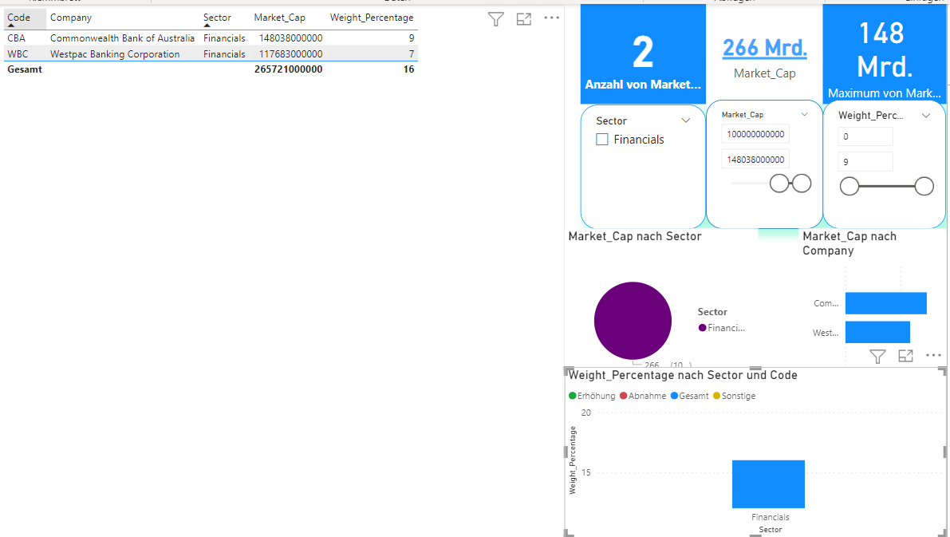

# Chapter 2: Joining Analysis on two files, primary.asx200 and a secondary one.

After importing the second file, and changing the names of sheets and files, it is viewed that the Power BI itself automatically chose the joining criteria based on Code columns.

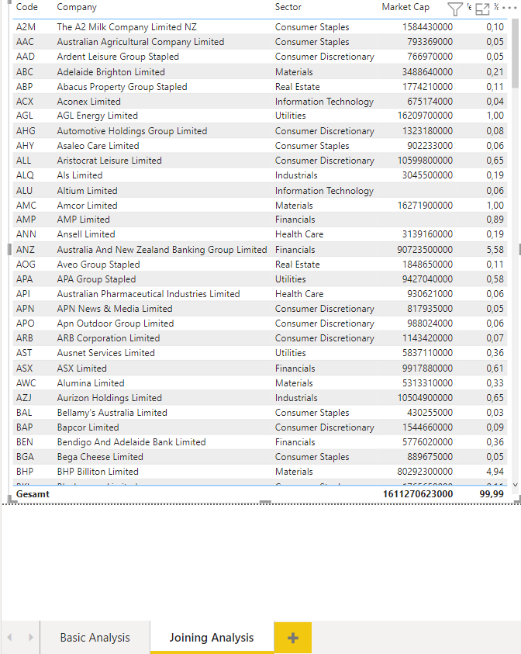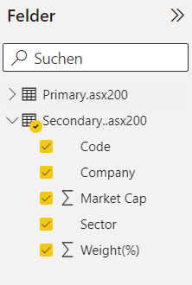

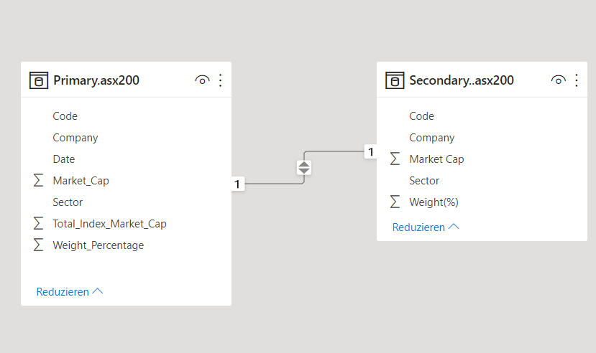

The secondary data does not contain the sector and weight columns, as they have been deliberately canceled out. However, by joining them and using the missing columns from the primary dataset, it is possible to predict the missing information based on the complete table.

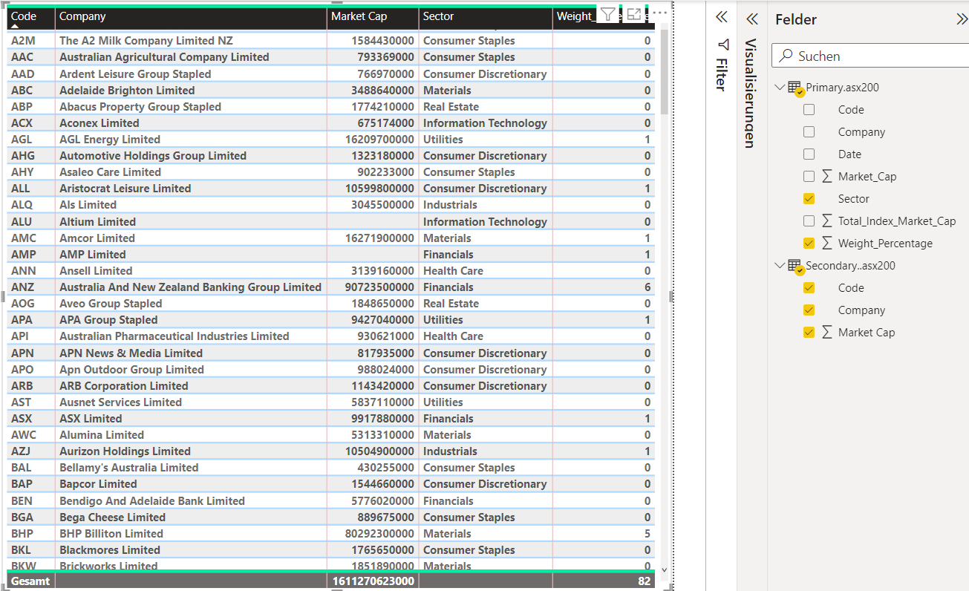

## **Assessing the power of Power BI**

By comparing the last joining by sorting the weight with the real weights of the secondary table of asx200 we can check to what extent the software is accurate. To do that firstly the joining table is sorted out based on the weight column, presented below.

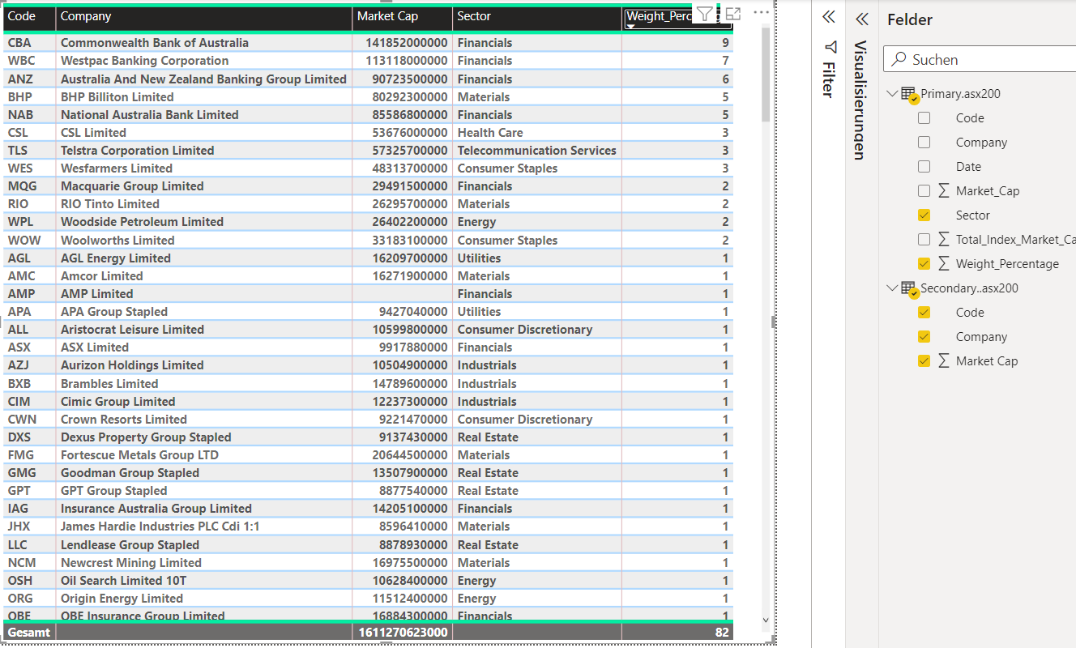

The second screenshot is the secondary table with complete data, including the original columns of weight and sector. The result is great, for example, the prediction for CBA, WBC, and ANZ is just a little more than the real ones, 9 for 8.72, 7 for 6.95, and 6 for 5.58 respectively.

